**DAILY ONLINE ACTIVITIES SUMMARY**

|  |  |  |  |  |  |  |  |  |
| --- | --- | --- | --- | --- | --- | --- | --- | --- |
| **Date:** | 01/06/2020 | | | | | **Name:** | CHANDANA S | |
| **Sem & Sec** | 4th SEM ‘A’ SEC | | | | | **USN:** | 4AL18CS016 | |
| **Online Test Summary** | | | | | | | | |
| **Subject** | | Complex Analysis, Probability and Statistical Methods(18MAT41) | | | | | | |
| **Max. Marks** | | 30 | | **Score** | | | 29 | |
| **Certification Course Summary** | | | | | | | | |
| **Course** | Cloud Computing with AWS | | | | | | | |
| **Certificate Provider** | | | Great Learning | | **Duration** | | | 3 Hours |
| **Coding Challenges** | | | | | | | | |
| **Problem Statement:** 1. Write a java program to calculate the distance between points p1 and p2. | | | | | | | | |
| **Status:** Completed | | | | | | | | |
| **Uploaded the report in Github** | | | | | YES | | | |
| **If yes Repository name** | | | | | https://github.com/chandushivalingareddy/lockdown-coding | | | |
| **Uploaded the report in slack** | | | | | YES | | | |

**Online Test Details:**

The online test was from module 5 which was about the Joint Probability Distribution and Sampling theory. There were 20 questions and the duration was 40 minutes. The questions were optimal and were easy. The score that I got in the test is 29/30.

**Snapshot:**

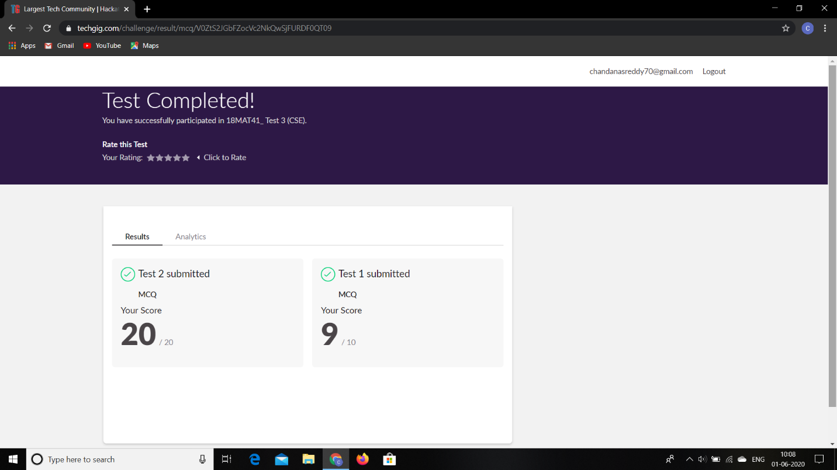

**Certification Course Details:**

**Name of the course**: Cloud Computing with AWS

**Certificate Provider**: Great Learning

Today I went through the six modules of the course that explained about Auto Scaling, AMI, AWS CLI and Storage and VPC, Route53, WAF.

**Snapshot:**

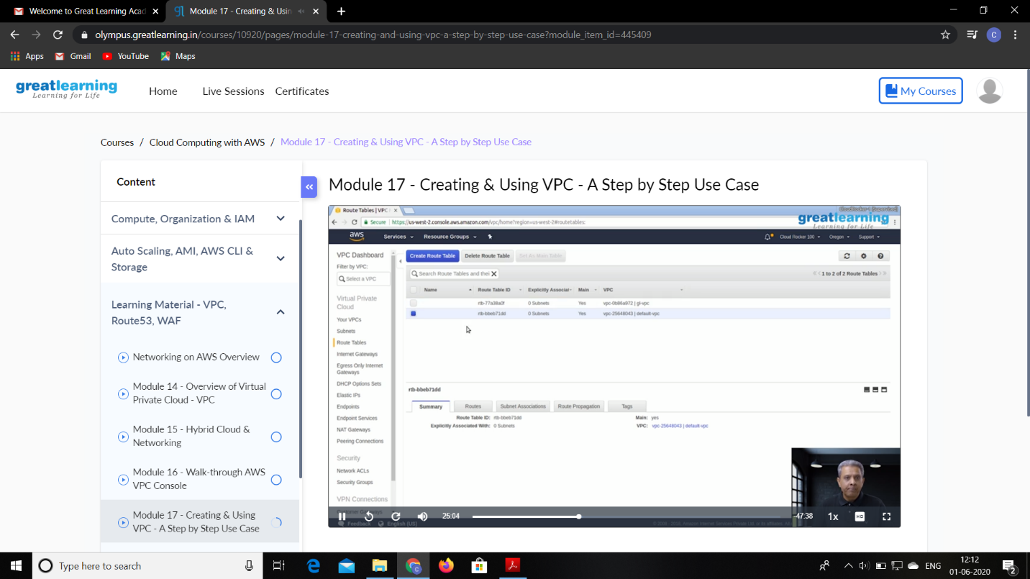

**Online Coding Details:**

Problem 1: (using Java language) to calculate the distance between points p1 and p2.

**Snapshot:**

